**Connecting Social Media to E-Commerce: Cold-Start Product Recommendation Using Microblogging Information**

**ABSTRACT:**

In recent years, the boundaries between e-commerce and social networking have become increasingly blurred. Many e-commerce websites support the mechanism of social login where users can sign on the websites using their social network identities such as their Facebook or Twitter accounts. Users can also post their newly purchased products on microblogs with links to the e-commerce product web pages. In this paper, we propose a novel solution for cross-site cold-start product recommendation, which aims to recommend products from e-commerce websites to users at social networking sites in “cold-start” situations, a problem which has rarely been explored before. A major challenge is how to leverage knowledge extracted from social networking sites for cross-site cold-start product recommendation. We propose to use the linked users across social networking sites and e-commerce websites (users who have social networking accounts and have made purchases on e-commerce websites) as a bridge to map users’ social networking features to another feature representation for product recommendation. In specific, we propose learning both users’ and products’ feature representations (called user embeddings and product embeddings, respectively) from data collected from e-commerce websites using recurrent neural networks and then apply a modified gradient boosting trees method to transform users’ social networking features into user embeddings. We then develop a feature-based matrix factorization approach which can leverage the learnt user embeddings for cold-start product recommendation. Experimental results on a large dataset constructed from the largest Chinese microblogging service SINA WEIBO and the largest Chinese B2C e-commerce website JINGDONG have shown the effectiveness of our proposed framework.

**EXISTING SYSTEM:**

* Most studies only focus on constructing solutions within certain e-commerce websites and mainly utilise users’ historical transaction records. To the best of our knowledge, cross-site cold-start product recommendation has been rarely studied before.
* There has also been a large body of research work focusing specifically on the cold-start recommendation problem.
* Seroussi et al. proposed to make use of the information from users’ public profiles and topics extracted from user generated content into a matrix factorization model for new users’ rating prediction.
* Zhang et al. propose a semi-supervised ensemble learning algorithm.
* Schein proposed a method by combining content and collaborative data under a single probabilistic framework.
* Lin et al. addressed the cold-start problem for App recommendation by using the social information.

**DISADVANTAGES OF EXISTING SYSTEM:**

* They only focus on brand or category-level purchase preference based on a trained classifier, which cannot be directly applied to our cross-site cold start product recommendation task.
* Their features only include gender, age and Facebook likes, as opposed to a wide range of features explored in our approach.
* They do not consider how to transfer heterogeneous information from social media websites into a form that is ready for use on the e-commerce side, which is the key to address the cross-site cold-start recommendation problem.

**PROPOSED SYSTEM:**

* In this paper, we study an interesting problem of recommending products from e-commerce websites to users at social networking sites who do not have historical purchase records, i.e., in “cold-start” situations. We called this problem cross-site cold-start product recommendation.
* In our problem setting here, only the users’ social networking information is available and it is a challenging task to transform the social networking information into latent user features which can be effectively used for product recommendation. To address this challenge, we propose to use the linked users across social networking sites and e-commerce websites (users who have social networking accounts and have made purchases on e-commerce websites) as a bridge to map users’ social networking features to latent features for product recommendation.
* In specific, we propose learning both users’ and products’ feature representations (called user embeddings and product embeddings, respectively) from data collected from e-commerce websites using recurrent neural networks and then apply a modified gradient boosting trees method to transform users’ social networking features into user embeddings.
* We then develop a feature-based matrix factorization approach which can leverage the learnt user embeddings for cold start product recommendation.

**ADVANTAGES OF PROPOSED SYSTEM:**

* Our proposed framework is indeed effective in addressing the cross-site cold-start product recommendation problem.
* We believe that our study will have profound impact on both research and industry communities.
* We formulate a novel problem of recommending products from an e-commerce website to social networking users in “cold-start” situations.
* To the best of our knowledge, it has been rarely studied before.
* We propose to apply the recurrent neural networks for learning correlated feature representations for both users and products from data collected from an e-commerce website.
* We propose a modified gradient boosting trees method to transform users’ microblogging attributes to latent feature representation which can be easily incorporated for product recommendation.
* We propose and instantiate a feature-based matrix factorization approach by incorporating user and product features for cold-start product recommendation

**SYSTEM ARCHITECTURE:**

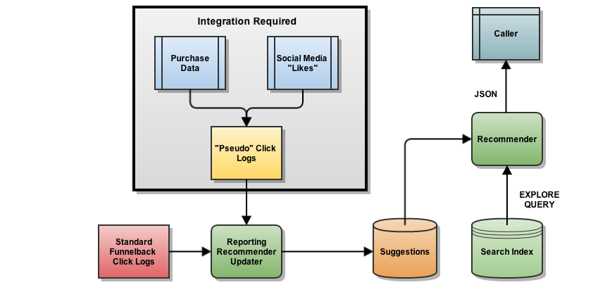

**SYSTEM REQUIREMENTS:**

**HARDWARE REQUIREMENTS:**

* System : Pentium Dual Core.
* Hard Disk : 120 GB.
* Monitor : 15’’ LED
* Input Devices : Keyboard, Mouse
* Ram : 1GB.

**SOFTWARE REQUIREMENTS:**

* Operating system : Windows 7.
* Coding Language : JAVA/J2EE
* Tool : Netbeans 7.2.1
* Database : MYSQL

**REFERENCE:**

Wayne Xin Zhao, Member, IEEE, Sui Li, Yulan He, Edward Y. Chang, Ji-Rong Wen, Senior Member, IEEE, and Xiaoming Li, Senior Member, IEEE, “Connecting Social Media to E-Commerce: Cold-Start Product Recommendation Using Microblogging Information”, **IEEE TRANSACTIONS ON KNOWLEDGE AND DATA ENGINEERING, VOL. 28, NO. 5, MAY 2016.**